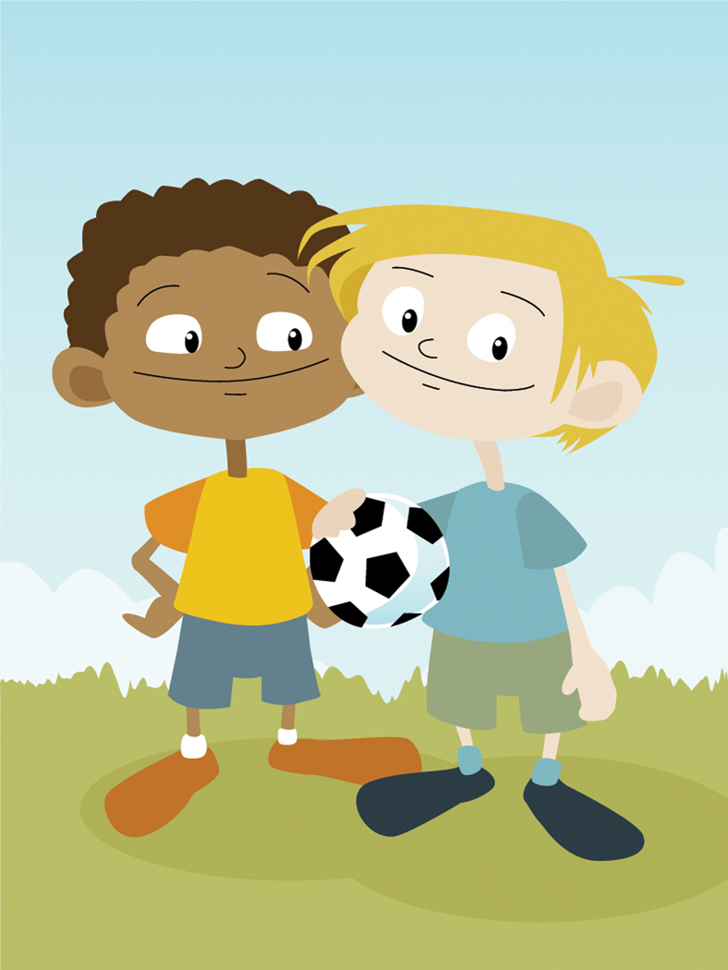  ACTIVITIES |   WORDS TO CHECK |   THINGS TO CHECK
Hi! | audio-visual room  mobile phone  video clips  library | Write the names of the two teachers.  Write the names of your grade 8 friends.
“Knuffle Bunny” | bunny  toy rabbit  New York  laundromat  laundry  bookmark | Can you find the missing words?  For Trixie, Knuffle Bunny is important because it is her _____ _____ .  For Trixie’s parents, Knuffle Bunny is important because “Knuffle” and “Bunny” are Trixie’s _____ _____ .
Please Follow the Map! | mind map  water fountain  toilet | How many ideas did you give your friends?
BREAK
Enjoy the Tour! | dorm  cafeteria  tunnel  graffiti  Macedonia Hall  history  brick  flag  stars and stripes | Write a question about Anatolia College.  (Don’t forget to email it to your friends!)
Our Story | notebook  outdoor theater  bench  steps | Write and draw:  What did you see? What did you do?  What did you like?  How do you feel? Why?
Let’s Play Tic-Tac-Toe! |  | Read the rules of the game:  - Pink = O Red = X  - Choose a square and say the word.  - Describe the thing.  - If you are right, throw your bag into the square.  - If your bag doesn’t go in the square, you don’t win the square.

